**hostPath volumes:**

* the difference between emptyDir and host path is the data. The data will be deleted in emptyDir when POD dies. But the data will be available in hostPath even the POD dies and the same can be used again in any pod which gets scheduled on the same node.
* But there won’t be any data sync between the node of hostPath. So, we need to be very careful using hostPath.

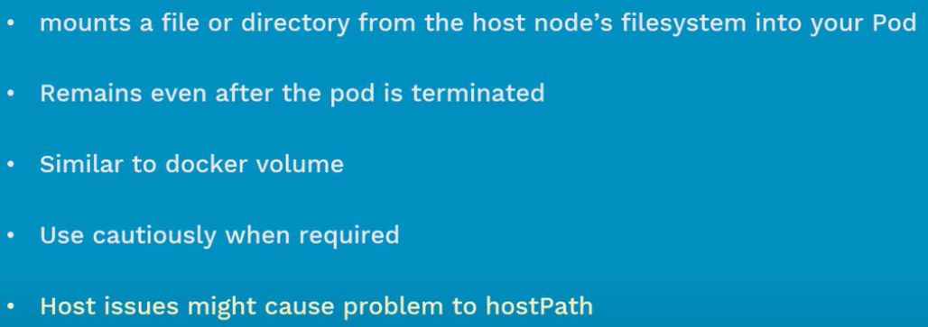

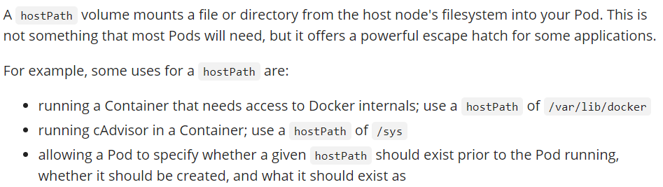

**Manifest file:**

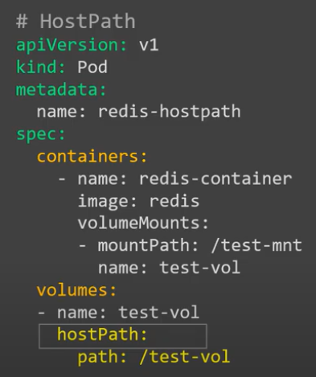

* We can also use “type” option along with hostPath. Below or the options to use.

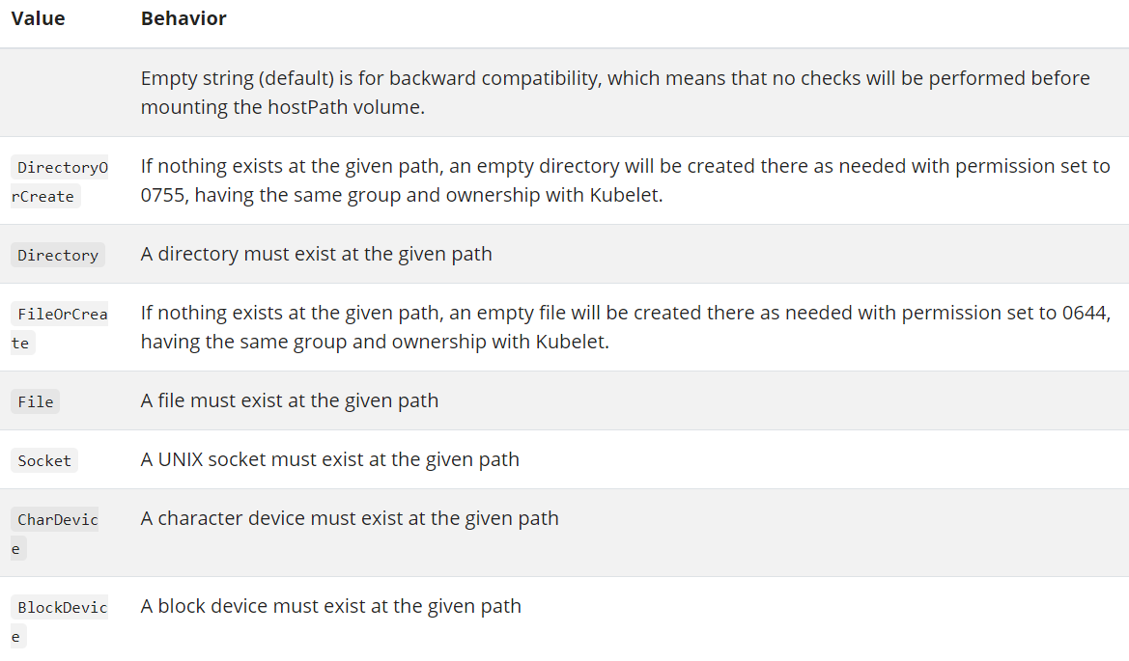

* More yaml examples on this below.

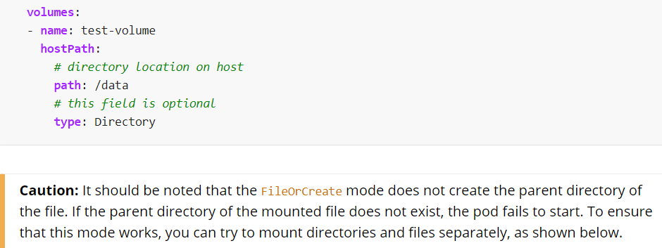

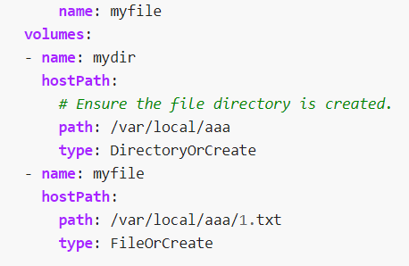

**Create and display:**

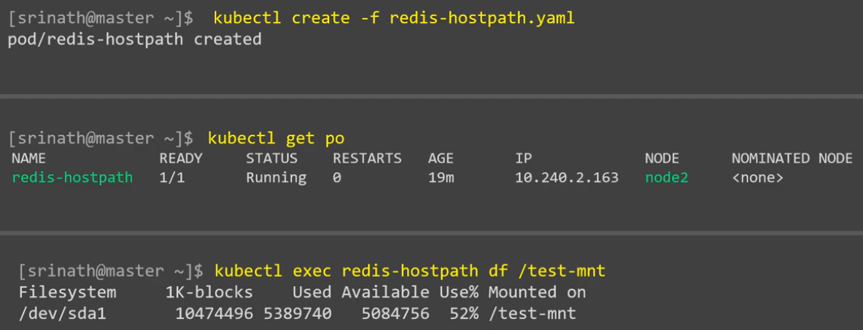

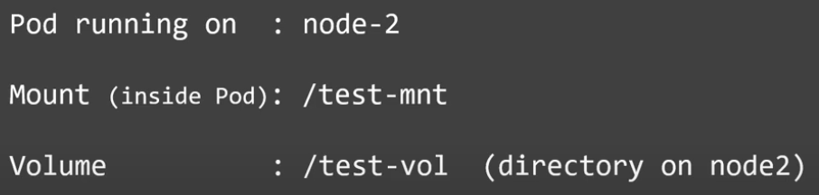

**Test:**

* Now, as per the above example the volume directory “/test-vol” got created on node2 and the same will be in sync with the mount path “/test-mnt” inside the POD. Just like docker volumes.

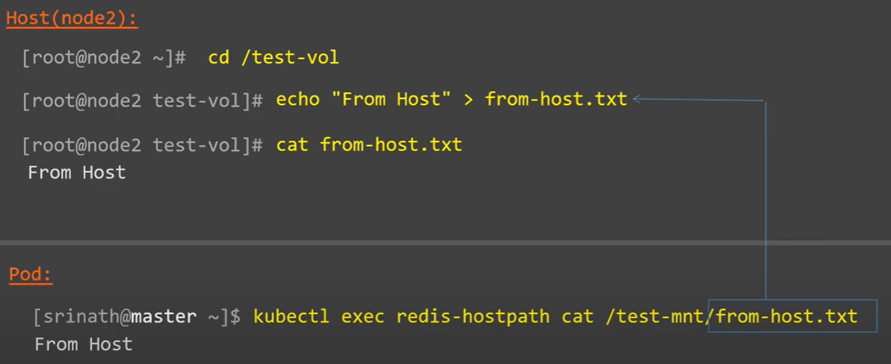

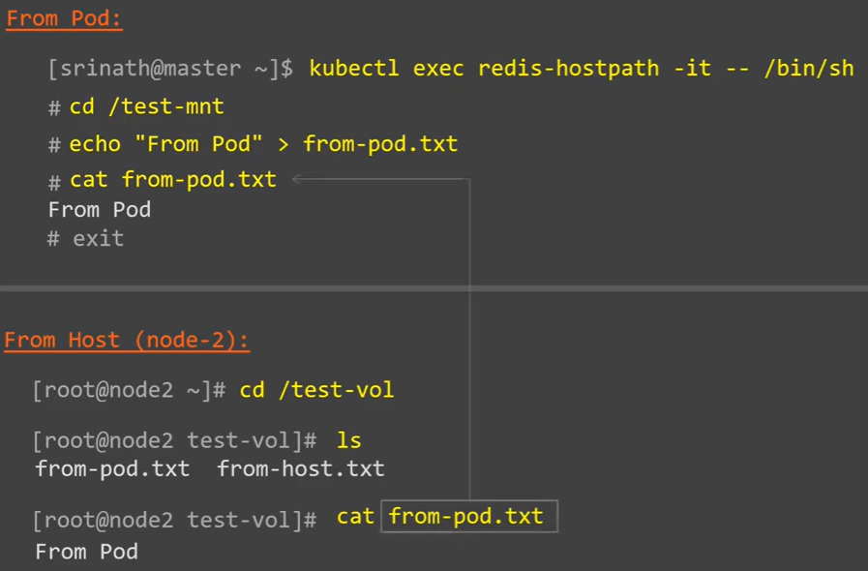

**Delete:**

